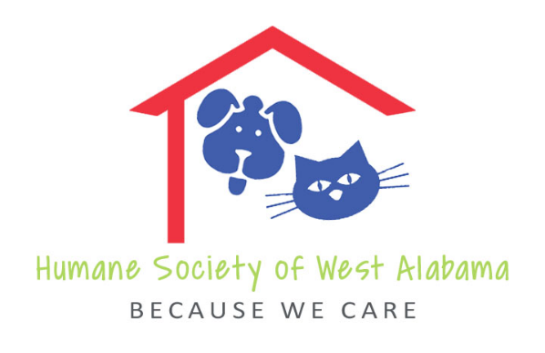

The Humane Society of West Alabama
P.O. Box 70054 Tuscaloosa, AL 35407 humanesocietyofwa.org 205 – 554-0011

17th Annual Canine Classic 5K Road Race
Saturday, September 14, 2019
Sponsorship Commitment

There are four levels of sponsorship. Please mark your sponsorship level and return this form and your check by August 16. If you choose Grand Champion or Champion level, please include your company logo (electronic or print form).

⁭ GRAND CHAMPION $1,000.00
Company Name/Logo (HUGE) on T-Shirt
Company Name in All Advertising
Company Name/Logo on Banner at Event
Program Acknowledgement
3 Complimentary Race Entries

⁭ CHAMPION $500.00
Company Name/Logo (large) on T-Shirt
Company Name/Logo on Banner at Event
Company Name in All Advertising
Program Acknowledgement
2 Complimentary Race Entries

⁭ BEST IN SHOW $250.00
Company Name/Logo on Banner at Event
Company Name in All Advertising
Program Acknowledgement
1 Complimentary Race Entry

⁭ BEST IN BREED $100.00
Company Name/Logo on Banner at Event
Program Acknowledgement

All sponsors may provide an item with company/logo for race packet insertion.
All sponsors will be recognized on Sponsor Thank You Flyer in the runner’s race packet.

Company Name
Address
City State Zip Code
Phone FAX E-mail Address
Contact Person

